Resolution

Senate Resolution No. 2025/2026 - 120
Retaining Administration of the Multicultural Initiative Fund (MIF) Under the Office of the President

Primary Sponsor
Abigail Verino (ASUC President), Jonathan Ngai (ASUC Chief Financial Officer)
Cosponsors
-

WHEREAS, the Office of the President’s (OP) Multicultural Initiative Fund (MIF) is an annual $75,000 grant that comes from the Chancellor’s Advisory Committee on Student Services and Fees (CACSSF), in addition to unallocated funds from the previous year, from the Vice Chancellor of Student Affairs (VCSA) Office, which financially supports Registered Student Organizations (RSOs) and ASUC Offices that uplift one or more cultural groups within the UC Berkeley student body; and,

WHEREAS, the MIF grant is managed by the MIF Department under the OP, which tasks members to promote the MIF grant among RSOs, interview RSO applicants, properly allocate the MIF grant to eligible RSOs, and ensure the success of student-led diverse events and programs; and,

WHEREAS, the MIF application requires RSOs and ASUC Offices to submit a detailed proposal and a budget breakdown, providing insight into how an RSO or ASUC Office would use the funds allocated from the MIF grant; and,

WHEREAS, this year in the OP, the MIF Department received 80 applications and invited 79 applicants for interviews; and,

WHEREAS, the final allocation of the MIF grant was $110,000 in the 2025-2026 year was allocated to 62 organizations, including the Black Student Union, the East Asian Union, and the Queer Alliance & Resource Center; and,

WHEREAS, SR 23-24 -049 was a resolution seeking to address concerns about the MIF allocations process, including, transparency, equity, consistency, and communication from RSOs who applied for MIF; and,

WHEREAS, SR 049 further sought to address large funding gaps, inconsistent communication on the process, unspent funds, and timely advertising for organizations to get information on applications; and,

WHEREAS, SR 23-23-49 called for the administration of MIF to be moved from the OP to the Grants and Scholarships Fund (GSF), with the OP being granted a grace period of 5 years, meaning that MIF will be moved to the GSF in the upcoming academic year; and

WHEREAS, the OP has worked to address these points of contention by initiating an internal evaluation framework, establishing departmental correspondence, and hosting two comprehensive informational sessions to ensure that RSOs were fully aware of the application and interview processes; and,

WHEREAS, the OP established a liaison program where department members conduct check-ins and assist RSOs with Callink Stage 1 requests to guarantee efficient allocation of funds; and,

WHEREAS, the OP has publicized the MIF application through ASUC channels, including social media and the ASUC website; and,

WHEREAS, the OP hosted a Multicultural RSO Mixer to further publicize the MIF application and reach out to eligible organizations; and,

WHEREAS, the OP established a centralized communication in the mif@asuc.org email address; and,

WHEREAS, the OP created and disseminated communication and marketing materials concerning the Multicultural Initiative Fund, including newsletters, social media posts, and other public-facing outreach for accountability purposes; and,

WHEREAS, the OP ensured that the MIF publicized a clear timeline that includes the application deadline, the application review deadline, and the time of the appeal window if an appeal is available for that year, on its application form, the OASIS email, and all Instagram advertisements; and,

WHEREAS, the OP has addressed the absence of a grading scale in the MIF decision-making process by adopting a formal rubric within the MIF application, using rubric-based questions throughout the proposal section, and explicitly providing that interviewer questions will closely follow the same evaluative criteria, thereby establishing a standardized framework to guide assessment and funding determinations in addition to existing deliberations; and,

WHEREAS, the CFO is responsible for the storage and analysis of financial information as per ASUCBL 1402§2.11; and,

WHEREAS, the CFO is responsible for acting as the Treasurer of the ASUC and ensuring financial health of the ASUC per ASUC Constitution Article III-B, Section 2 and ASUCBL 1402§2.1; and,

THEREFORE BE IT RESOLVED, the Senate hereby calls for the Office of the President to retain administration of the Multicultural Initiative Fund, hereby reversing the position of the Senate under SR 23/24-049 to transfer this administration under the ASUC Grant & Scholarship Fund; and,

THEREFORE BE IT FURTHER RESOLVED, the MIF shall disclose the MIF funds allocations and evaluations of MIF applicants to the Office of the Chief Financial Officer (OCFO) system, and the Senate reaffirms its position under SR 23/24-049 that “the MIF is administered under a stable institution in a transparent and equitable manner”; and,

THEREFORE BE IT RESOLVED, that the Chief Financial Officer or an approved designee be a non-voting Ex-Officio member of all meetings related to the administration of, allocation of funds from and disbursement of funds from MIF.

THEREFORE BE IT RESOLVED, that the Associated Students of the University of California will currently subject MIF to ASUCBL 2150 and finance operational policies; and,

THEREFORE BE IT RESOLVED, that the Associated Students of the University of California amend ASUCBL 2150 as listed in Appendix C; and,

THEREFORE BE IT FINALLY RESOLVED, the OP Multicultural Initiative Fund (MIF) shall, in collaboration with the Office of the Chief Financial Officer (OCFO), develop a Memorandum of Understanding (MOU), which shall govern the relationship between the two offices, and ensure further transparency and equity measures in the management of MIF as described in Appendix D.

Appendix A

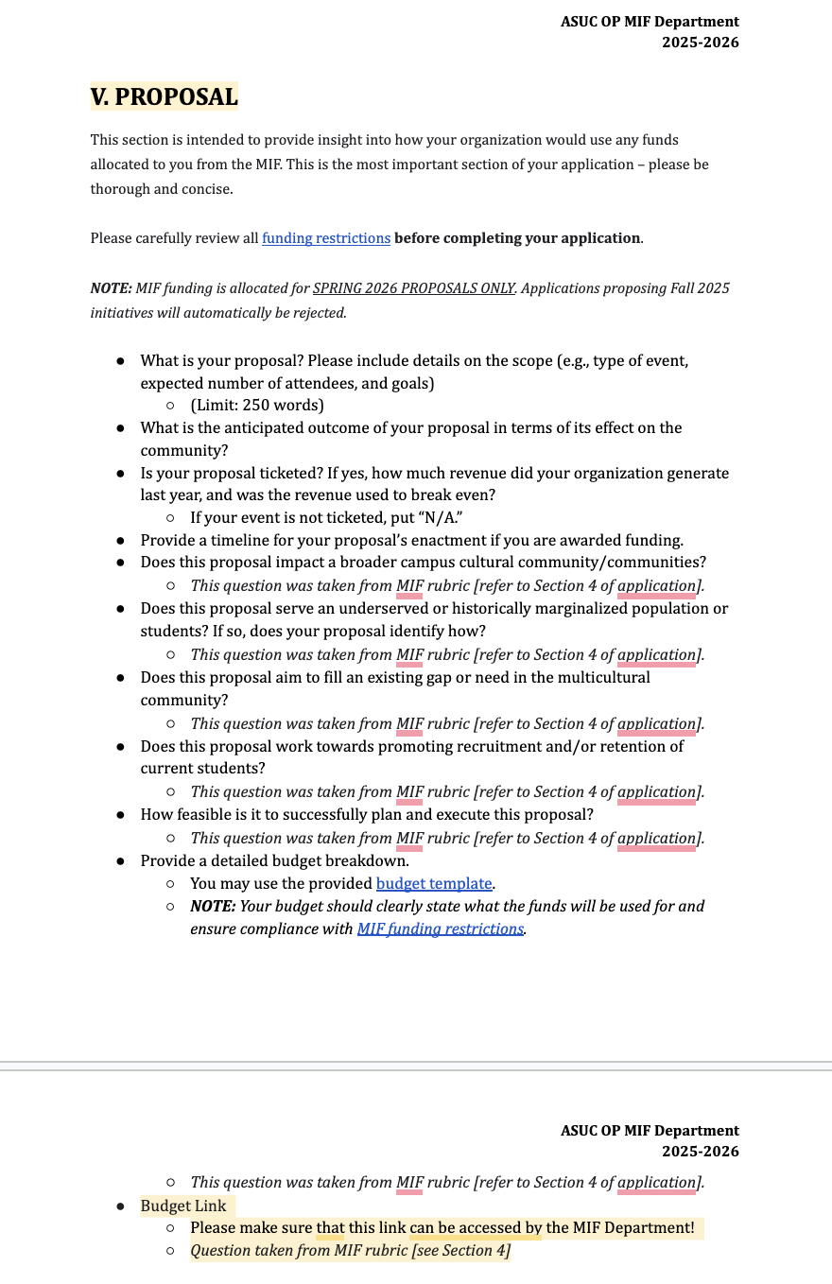
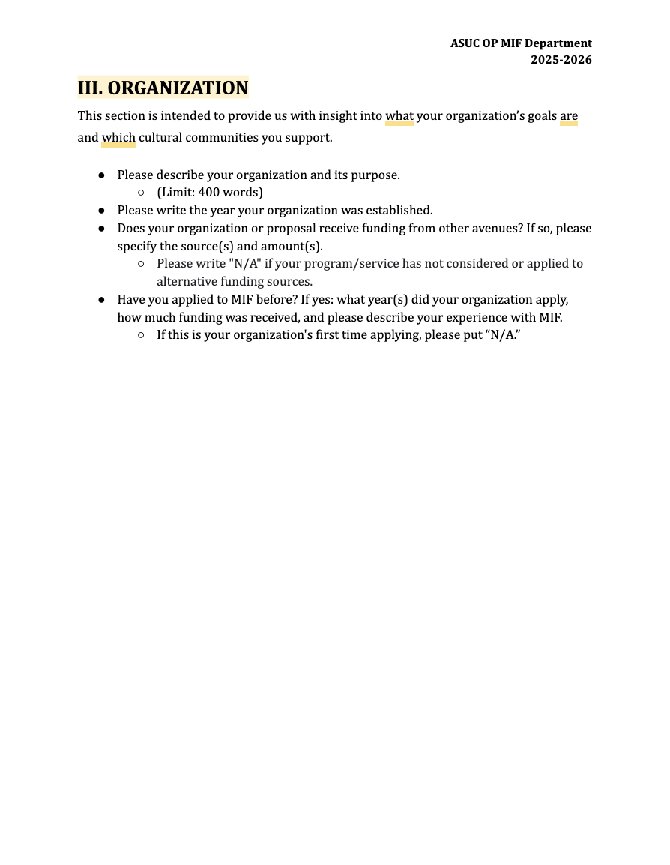

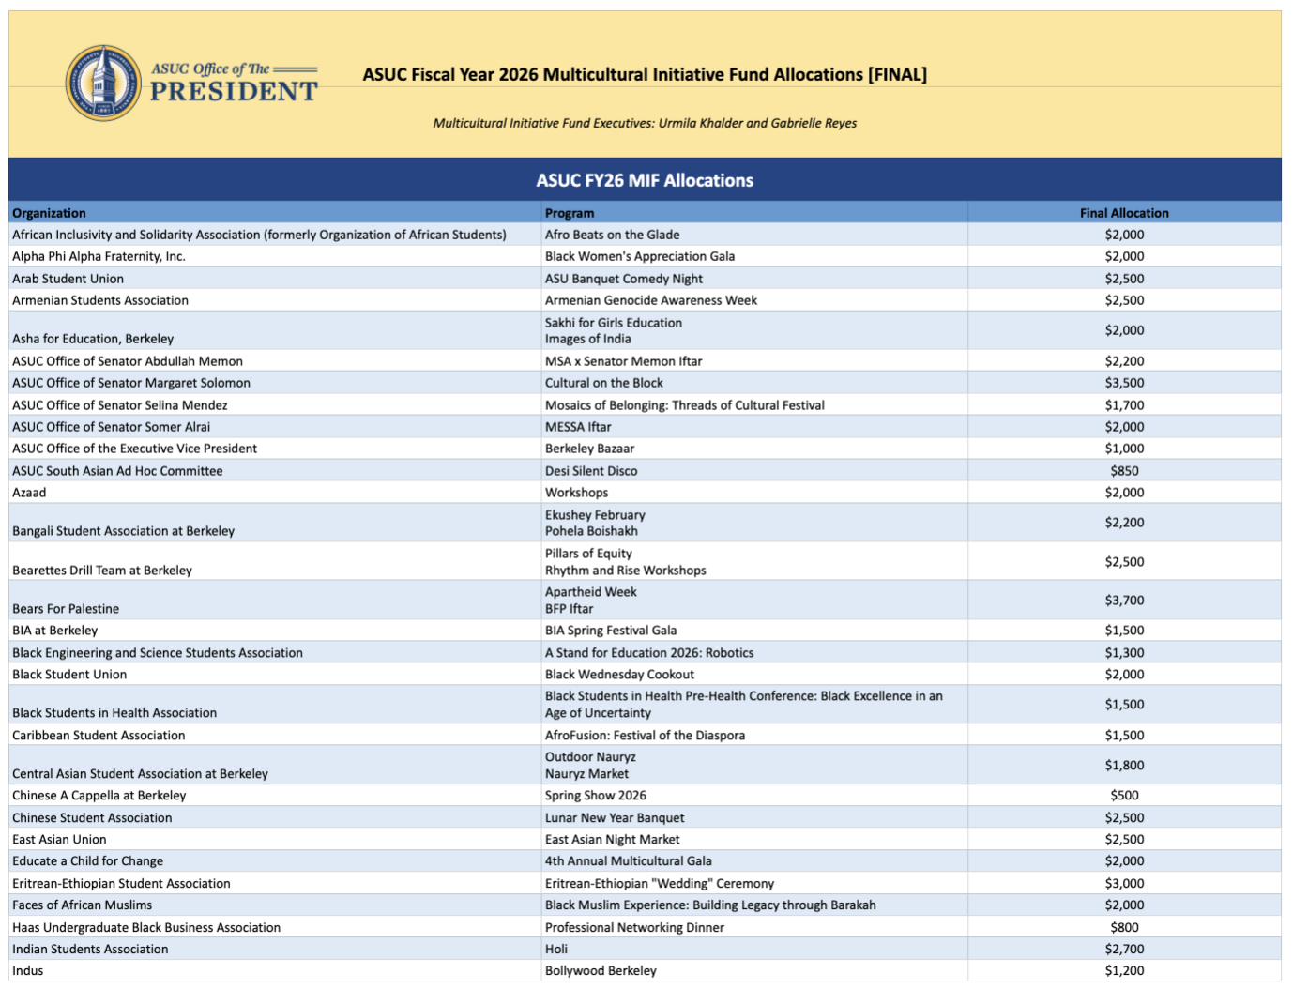

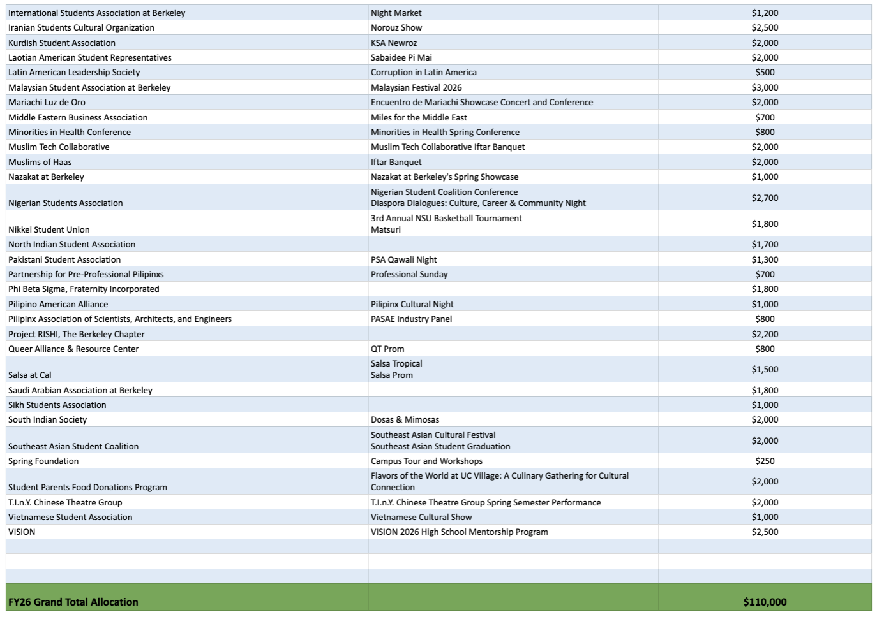

Appendix B

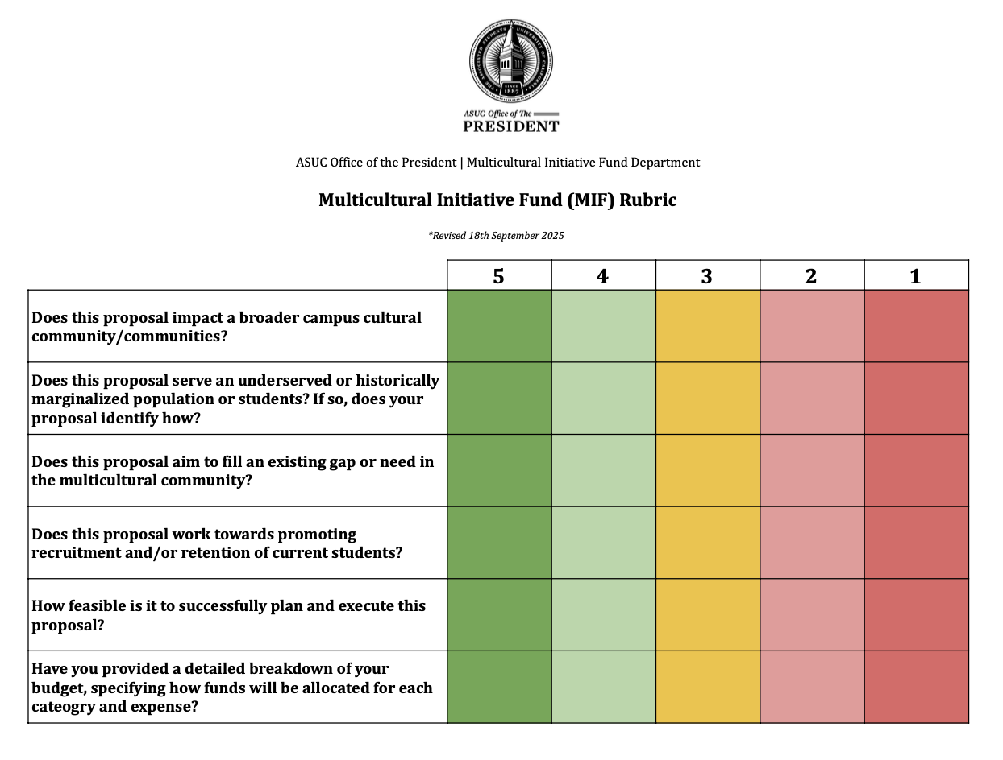

Appendix C

ASUCBL 2150: Spending Restrictions

Section 1: Establishment
1.1 As this bylaw is intended to prevent financial irresponsibility, which could jeopardize the mission of the ASUC, this bylaw shall not be waived or suspended by the Senate.
Section 2: Waivable ASUC Spending Restrictions
2.1 Pursuant to Article VI, Section 8 of the Constitution, all financial restrictions enumerated in this section may be waived or modified by the Senate Finance Committee for specific operational units or groups; however, the Senate retains final authority. No waiver shall be granted more than five regular ASUC Senate meetings after the event and/or purchase date except in the case of reimbursement as provided in §2.2.3, §2.2.4, and §2.2.5 of this bylaw, or by a two-thirds vote of the Senate.
2.2 No ASUC funds may be used to:
2.2.1 Purchase food and beverages
2.2.1.1 For a given fiscal year, no more than 30% of an organization’s ABSA funding shall be waived to purchase food and beverages for any ASUC-sponsored organization from external entities except through Student Union Catering.
2.2.1.2 If a Student Organization uses more than 50% of their total ASBA allocation in the given year on food-related spending, the following penalties will apply:
2.2.1.2.1 They are no longer eligible for Senate Contingency funding for the fiscal year in which this occurred.
2.2.1.2.2 Student Organizations shall require a financial rule waiver for the purchase of food through Student Union Catering.

2.2.3 Purchase or reimburse a group for flyers or posters that do not display the words “Sponsored by the ASUC” or "ASUC”.
2.2.4 Purchase or reimburse a group for flyers or posters promoting an event that do not indicate the degree of wheelchair accessibility to the event described by the flyer.
2.2.5 Pay for travel or accommodation outside the Bay Area (Bay Area consists of nine counties); 1) Alameda, 2) Contra Costa, 3) Marin, 4) Napa, 5) San Francisco, 6) San Mateo, 7) Santa Clara, 8) Solano, and 9) Sonoma;
2.2.6 Pay for any prizes and gifts for individuals, which shall be defined as any good or service provided to an individual for personal benefit. See Finance 004 for clarifying examples on what items are and are not considered a gift.
2.2.7 Purchase non-essential latex products such as balloons and rubber bands. Contraceptives or personal protective equipment shall not be included in this definition.
Section 3: Non-Waivable ASUC Spending Restrictions
3.1 Pursuant to Article VI, Section 8 of the Constitution, the Senate retains final authority, and will work in consultation with the CFO on delineating between non-waivable and waivable ASUC spending restrictions.
3.2 No ASUC funds may be used for the following expenses with no exceptions or waivers whatsoever:
3.2.1 individual, single-use water bottles
3.2.2 Purchase glossy or plastic-finished flyers
3.2.3 Fund any activity or travel that would require ASUC funds to be spent to cross an active strike, lockout, boycott, or other bona fide labor dispute in accordance with §3.1 of this bylaw.
3.2.4 Pay for insurance premiums for events on campus
3.2.5 Purchase alcoholic beverages or illegal substances
3.2.6 Fund any activity or group that discriminates in its method of recruitment and acceptance for membership as per Article VI, Section 7, Subsection C of the ASUC Constitution or on the basis of gender identity, immigration status, mental ability, or socioeconomic status.
3.2.7 Fund off-campus political activities - such as local, state, or national political campaigns, candidates, or ballot initiatives.
3.2.7.1 This shall not preclude the ASUC from providing monies for educational initiatives or to publicize positions taken by the Senate.
3.2.7.1.1 Neither educational initiatives nor publicized positions may ask the public to adopt a specific position.
3.2.8 Using funds to reimburse gas for automobile travel as per Finance 002.
3.2.9 Fund any social retreat or party, including any activity/expense relating to the planning, operation or supplying of a retreat or party for any registered student organization or ASUC unit. There are numerous events with social aspects that do not count as a social retreat or party and thus are not subject to restriction. Refer to Finance 004 for specific clarifications.

Section 4: ASUC Financial Solidarity with Organized Labor
4.1 The ASUC shall consult with the ASUC Office of the External Affairs Vice President and/or the Labor Action Tracker by the Cornell University School of Industrial and Labor Relations & the University of Illinois Urbana-Champaign School of Labor and Employment Relations to ensure that labor-related issues are given due consideration at every event with an estimated cost of over $1,000, an estimated attendance of over 300 individuals, or otherwise would be categorized as a Major Event per the UC Berkeley Major Events Policy. To facilitate efforts to utilize union-made goods and services related to the ASUC.
4.2 If the ASUC or any of its sponsored RSOs plan to hold a meeting or event at an off-campus non-union facility, the following conditions shall be met:
4.2.1 No suitable union facility exists in the area.
4.2.2 The entity shall prepare a report regarding its efforts to locate a unionized provider, any communications with the ASUC Office of the External Affairs Vice President, and its reasons for selecting a non-union provider to facilitate future purchases from unionized providers. That report shall be available to the public.
4.2.3 Notwithstanding any of the above, the ASUC and its entities shall not hold any events, meetings, or otherwise monetarily support a facility or business where a strike, lockout, boycott, or other bona fide labor dispute exists and shall not cross a bona fide labor picket line for any reason.
4.2.4 The ASUC and its entities shall take similar precautions to avoid holding any events, meetings, or otherwise monetarily supporting a facility that is the subject of a boycott or other bona fide protest concerning its human rights or environmental policies.
4.3 As to expenditures of $1,000 or more that may be spent on goods, printing, or events by the ASUC and its entities for use in daily operations or for special occasions such as meetings, demonstrations, delegations, and the like, it is the policy of the ASUC that such shall be obtained, whenever possible, from companies or worker-owned and controlled cooperatives which have collective bargaining agreements with a bona fide labor organization.
4.4 Whenever possible, products shall also display the union bug or label when such products will also display the ASUC logo or are otherwise identified with the work of the ASUC.
4.5 If there is no unionized provider locally, before utilizing a non-union provider, the requesting party shall notify the ASUC Office of the External Affairs Vice President to timely provide assistance or guidance in locating a unionized provider.
4.6 Should non-union goods or services of $1,000 or more be purchased by an ASUC entity, the entity shall submit to the ASUC Finance Committee a report regarding its efforts to locate a unionized provider, any communications with the ASUC Office of the External Affairs Vice President, and its reasons for selecting a non-union provider. That statement shall be provided, in advance of the ASUC Finance Committee meeting, to the ASUC Office of the External Affairs Vice President so that the office may submit information to the ASUC Finance Committee to facilitate future purchases from unionized providers. That report shall be available to the public.
4.7 It is the policy of the ASUC that no ASUC entity shall hold an event at a facility where a strike, lockout, boycott, or other bona fide labor dispute exists, nor shall any ASUC member be required to cross a bona fide labor picket line to attend such an event. It is the policy of the ASUC that no ASUC entity shall purchase goods or services from a business where a strike, lockout, boycott or other bona fide labor dispute exists.

Section 5: ASUC Funding Programs with Distinct Spending Rules
5.1 Notwithstanding the restrictions enumerated in this section, the ASUC may establish specific funding opportunities or programs whose governing bylaws impose additional or mutated spending restrictions as follows:
5.1.1 The Public Campaign Financing Fund, established pursuant to ASUCBL 4204, is a funding program with district spending rules, as expressly authorized under this section and governed by the restrictions set forth in ASUCBL 4204 §9.
5.1.2 The Multicultural Initiative Fund (MIF), is a funding program with district spending rules, as expressly authorized under this section and governed by the restrictions set forth immediately below in ASUCBL 2150 §5.1.2.1.
5.1.2.1 All restrictions set forth in ASUCBL 2150, other than the ASUCBL §2.2.1 restricting purchase of food or beverages, shall apply to reimbursements issued or expenses paid through MIF.

Appendix D
MEMORANDUM OF UNDERSTANDING
BETWEEN
ASSOCIATED STUDENTS OF THE UNIVERSITY OF CALIFORNIA OFFICE OF THE PRESIDENT and ASSOCIATED STUDENTS OF THE UNIVERSITY OF CALIFORNIA OFFICE OF THE CHIEF FINANCIAL OFFICER
APRIL 17, 2026
This Memorandum of Understanding (“MOU”) is entered into by and between the Associated Students of the University of California Office of the President (“OP”) the Associated Students of the University of California Office of the Chief Financial Officer (“OCFO”), hereinafter referred to as “the Parties”, regarding the operations and administration of the ASUC Multicultural Initiative Fund (“MIF”) . In consideration of the OCFO’s financial advising and oversight role and the OP’s role as the administering body over MIF, OCFO and OP agree to be bound by all the terms and conditions of this MOU with respect to the operations and administration of MIF. This agreement will take effect upon its being signed by both Parties.
Background
ASUC is the officially recognized student association of the University of California, Berkeley.
This MOU outlines the terms of an arrangement under which the OP will operate MIF and OCFO will provide financial advice and oversight.
Agreement Terms .
I. MIF Minimum Publicization and Timeline Procedures
A. OP must administer and promote MIF while complying with the following bounds on publicization, timeline and application format, hereafter referred to as Minimum Publicization and Timeline Procedures (MPTPs):
- Application Timeline: OP will ensure that the MIF application window is open for at least two weeks during the Fall Semester and that the final deadline for applications is before November 15.
- Email Contact: OP will ensure an active and centralized email for communication about MIF in the form of the mif@asuc.org email.
- Office Hours and Infosessions: OP must host at least one office hour and at least one infosession lasting at least an hour long within five business days of the application deadline.
- Email Promotion: OP will make at least one Callink relay blast and/or email blast to all ASUC officials publicizing MIF prior to or during the first day of the application window. This promotional email must detail application deadlines, scheduled office hour and infosession details and how to contact OP with questions about MIF.
- Instagram Promotion: OP will make at least one instagram post promoting MIF prior to or during the first day of the application window. This promotional Instagram Post must detail application deadlines, scheduled office hour and infosession details and how to contact OP with questions about MIF.
- Senate Promotion: OP will present at least once at the Senate promoting MIF prior to or during the first day of the application window. This Senate presentation must detail application deadlines, scheduled office hour and infosession details and how to contact OP with questions about MIF.
- Final Decision Deadline: OP must have allocation decisions finalized and sent out to applicants prior to the first day of instruction during the Spring Academic Semester immediately following the Fall Academic Semester in which MIF applications were first collected.
B. OP may adopt additional publicization measures or modify the application timeline in ways that comply with the MPTPs. Examples include but are not limited to:
- Making the application window three weeks rather than one.
- Hosting more than just one infosession and office hour bloc or making an office hour bloc longer than the minimally required one hour.
- Making more than one instagram post promoting MIF.
- Publicizing final allocation decisions before finals week in the Fall semester rather than prior to the First day of instruction in the Spring semester.
II. Quantitative and Qualitative Data Disclosure for OCFO Oversight
A. OP will submit a Quantitative Data Disclosure that details applicant data and allocation decisions to the OCFO. This Quantitative Data Disclosure must at least include the following materials or information on the following subjects:
- An Applicant Tracking Spreadsheet recording all applicants, a description of applicant project proposals, how much was requested by each applicant for their proposal, whether the applicant progressed to an interview or not and the applicant’s final allocation amount.
  - The Applicant Tracking Spreadsheet must produce correct values for number of applications submitted, number of applications approved, total funding requested and total funding allocated.
- The total balance of the MIF account prior to the application cycle.
- Accessible links to or copies of any and all supplementary spreadsheets and documentation used by OP to track the finances of and make allocations from MIF.
B. OP will submit an Qualitative Data Disclosure that details the processes and procedures by which OP has administered MIF and assessed applications to the OCFO. This Qualitative Data Disclosure must at least include the following materials or information on the following subjects:
- Application forms through which applicants apply.
- Rubrics by which applicants are assessed.
- Timeline and procedural documentation used internally by OP to organize and administer MIF.
- Accessible links to or copies of any and all supplementary spreadsheets and documentation used by OP to organize and administer MIF.
C. OP will submit a Final Check-In Disclosure that details how applicants that were allocated MIF funds spent their money to the OCFO. This Final Check-In Disclosure must at least include the following materials or information on the following subjects:
- A record of purchase requests
  - The Applicant Tracking Spreadsheet must produce correct values for number of applications submitted, number of applications approved, total funding requested and total funding allocated.
- The total balance of the MIF after all disbursements for the application cycle have been made.
- Accessible links to or copies of any and all supplementary spreadsheets and documentation used by OP to administer disbursement and track usage of funds by applicants allocated MIF funding.
D. The Quantitative and Qualitative Data Disclosures must be submitted by OP to the OCFO by the end of the third week of instruction in the Spring Academic Semester immediately following the Fall Academic Semester in which applications were first collected. The Final Check-In Disclosure must be submitted by OP to the OCFO by the end of Reading/Review/Recitation Week in the Spring Academic Semester immediately following the Fall Academic Semester in which applications were first collected.
E. Formatting of all disclosures listed in this section will be determined by OCFO and communicated to OP at least ten business days prior to the disclosure submission deadlines OP needs to abide by.
F. OCFO will integrate MIF financial data and documentation from disclosures into its data handling system to ensure security of sensitive financial information and sound record keeping.
G. OCFO may utilize MIF financial data and documentation from disclosures listed in this section to assess the financial health of the ASUC as a whole, inform financial advice, inform audit procedures and assess the effective and equitable functioning of MIF as administered by OP.
- This will not be interpreted as barring OCFO from collecting, assessing the integrity of and utilizing financial data and documentation related to MIF or otherwise not directly disclosed from disclosures.
H. OP will not be barred from maintaining records of, performing transformations upon or distributing its own copies of financial data or documentation. However, OCFO is not responsible for maintaining the security of or validating any analysis performed on copies of financial data and documentation internally held within OP.
I. OP will not be barred from modifying its application process, though it must disclose any changes in information collected and operational procedures in the disclosures listed in this section.
III. OCFO Advising and Support for MIF
A. OCFO will grant requests by OP to access financial data to contextualize and inform MIF application decisions, provided that such requests are reasonable, ethical, feasible and comply with OCFO’s data access procedures. Examples of such contextualizing financial data include but are not limited to:
- OCFO Records of whether an MIF applicant has applied to and received ASUC Contingency or Space Reservation funding from the Senate Finance Committee
- OCFO Records of an MIF applicant’s financial health and any outstanding financial issues OCFO audits may have revealed.
B. OCFO will grant requests by OP to utilize and consult Financial Inspectors, trained in finance bylaw and best practices, to support OP’s administration of MIF by assisting with the development of rubrics, infosession materials, office hours or any other MIF materials, provided that such requests are reasonable, ethical, feasible and comply with OCFO’s Financial Inspector access procedures. OCFO will provide Financial Inspectors.
IV. Scope of Applicability
A. This MOU shall only apply to OP’s administering of MIF and OCFO’s advising and oversight of MIF.
B. This MOU will not apply to any other projects or initiatives of OP or OCFO.
C. OP shall retain its general powers to represent the ASUC as its top elected official, serve on committees and propose bylaw changes.
C. OCFO shall retain its general powers to ensure the financial health of the ASUC such as but not limited to its powers to produce documentation, draft bylaws, advice units and conduct audits and investigations.
D. If this MOU comes into conflict with official ASUC Bylaws, bylaws will prevail.
V. Dispute Resolution
A. Both parties will make good faith efforts to resolve issues promptly and collaboratively, acknowledging the mutually beneficial nature of this MOU in enabling the OP, as the top representative of the ASUC that has historically administered the MIF, to operate the fund, and the OCFO, as the top financial expert and oversight authority, to provide advising and oversight..
B. If unresolved, escalation to mediation agreed to by the Parties, including but not limited to Student Governance and Program Advising (SGPA).
C. Mediation shall be initiated within 10 business days of Impasse.
VI. Amendment
A. This MOU may be amended at any time by the mutual written consent of both Parties.
B. Amendments shall be documented in writing, signed by the then-current President and Chief Financial Officer, and attached as an addendum to this MOU.
VII. Termination
A. This MOU shall remain in effect for the duration of the current academic year and shall automatically renew on an annual basis.
B. This MOU may only be terminated by either Party in the event of a material breach by the other Party. The non-breaching Party must provide written notice detailing the breach. The breaching Party shall have 30 days from the receipt of such notice to cure the breach. If the breach remains uncured, the non-breaching Party may terminate the MOU upon an additional 15 days' written notice.
C. In the event of termination, the Parties agree to complete all ongoing MIF application cycles and disbursement processes initiated prior to the notice of termination to ensure no disruption to student applicants.
D. If any provision of this MOU is held to be invalid or unenforceable, the remaining provisions shall continue to be valid and enforceable.
This Memorandum of Understanding has been agreed upon by the following representatives on behalf of the Parties:
ASUC Signatories
________________________________ __________ ASUC President |Date Abigail Verino
________________________________ __________ ASUC Chief Financial Officer |Date Jonathan Ngai

Appendix A
Appendix A
SR 23/24-049 Reforming the Multicultural Initiative Fund to Improve Disbursement Processes and Transparency and Facilitate a potential transfer of the Administration of the Multicultural Initiative Fund from the Office of the President to the ASUC Grant & Scholarship Foundation
Appendix A
Appendix A
https://www.instagram.com/p/DPPP_JtEoBS/?utm_source=ig_web_copy_link&igsh=MzRlODBiNWFlZA==
Appendix B

